Yemi Atta Due: 11/03/2024

A vivid report displaying various charts and using various tools withing Tableau to create an interactive and appealing report.

Data Visualisation

Manipulating and Scrutinising Data

Table of Contents

Scenario 2

Policies and Procedures 3

Excel 5

*Connecting Data to Tableau to Build a Chart* 9

Data Visualisation with Tableau 14

Reflection 20

# Scenario

Data visualisation has become an essential business capability to help transform information into insights that can drive meaningful business outcomes and improved experiences. Today, most organizations have accumulated a wealth of data from the different corners of their businesses they are then unable to see how this data can help them make better decisions, making actions, and results. You have been asked to Look at the data workbook and familiarize yourself with this data. You have also been asked to create a visual report that will show the data in the form of charts and maps using Tableau to the client’s requirements. You will also need to consider data protection and computer misuse policies.

# Policies and Procedures

As Data Analyst, when working with data it is crucial to follow a set of policies and procedures, especially with sensitive or personal information, to ensure data security, privacy, and agreement. Depending on the type of data, the sector, and regulatory requirements, different rules may need to be followed to.

If you are using personal data, you must comply with the principles of the [EU General Data Protection Regulation (GDPR)](https://gdpr-info.eu/) and [Data Protection Act 2018 (DPA 2018)](https://www.legislation.gov.uk/ukpga/2018/12/contents/enacted) which implements aspects of the GDPR and transposes the [Law Enforcement Directive](http://eur-lex.europa.eu/legal-content/EN/TXT/?uri=uriserv:OJ.L_.2016.119.01.0089.01.ENG) into UK law. It also provides separate processing regimes for activities which fall outside the scope of EU law.

Everyone responsible for using personal data must follow strict rules called “data protection principles”. They must make sure the information is:

• Used fairly, lawfully, and transparently.

• Used for specified, explicit purposes.

• Used in a way that is adequate, relevant, and limited to only what is necessary.

• Accurate and, where necessary, kept up to date.

• Kept for no longer than is necessary.

• Handled in a way that ensures appropriate security, including protection against unlawful or unauthorised processing, access, loss, destruction, or damage.

As a Data Analyst, policies and procedures help employees to behave in a professional manner, which allows the organisation to achieve objectives more efficiently. Policies and procedures can also assist in meeting operational targets more efficiently.

There is stronger legal protection for more sensitive information, such as:

• Race/Ethnic background

• Political opinions

• Religious beliefs

• Trade union membership

• Genetics

• Biometrics (where used for identification)

• Condition of health

• Sexual orientation

These principles are necessary to protect data, respect regulations, maintain trust, and minimise risks. Organisations may guarantee that data is used responsibly and securely by implementing guidelines and treating it as a valuable information. Legal, financial, and reputation consequences may result from a failure to adhere to a data handling policy. This can lead to not only losing employment but also, tarnishing the name of a business.

# Excel

Protecting workbook

Protecting your workbook allows you to securely save and edit contents without unauthorised access to the data within the workbook. On the review ribbon at the top of the screen, you will find the ‘Protect Workbook’ icon. A pop-up window should appear; like the one below. Enter a password you will remember.

Changing data from USD to GBP

On the Ribbon at the top of your screen. If you click on the home tab, then click on general. A drop-down menu will show giving you options; select currency and excel will change the currency from USD to GBP. You could also use the accounting option in the same menu to separate the digits from the pound/dollar sign. This is a better option for accounting or scrutinising data without the pound/dollar sign interfering with some of the excel functions.

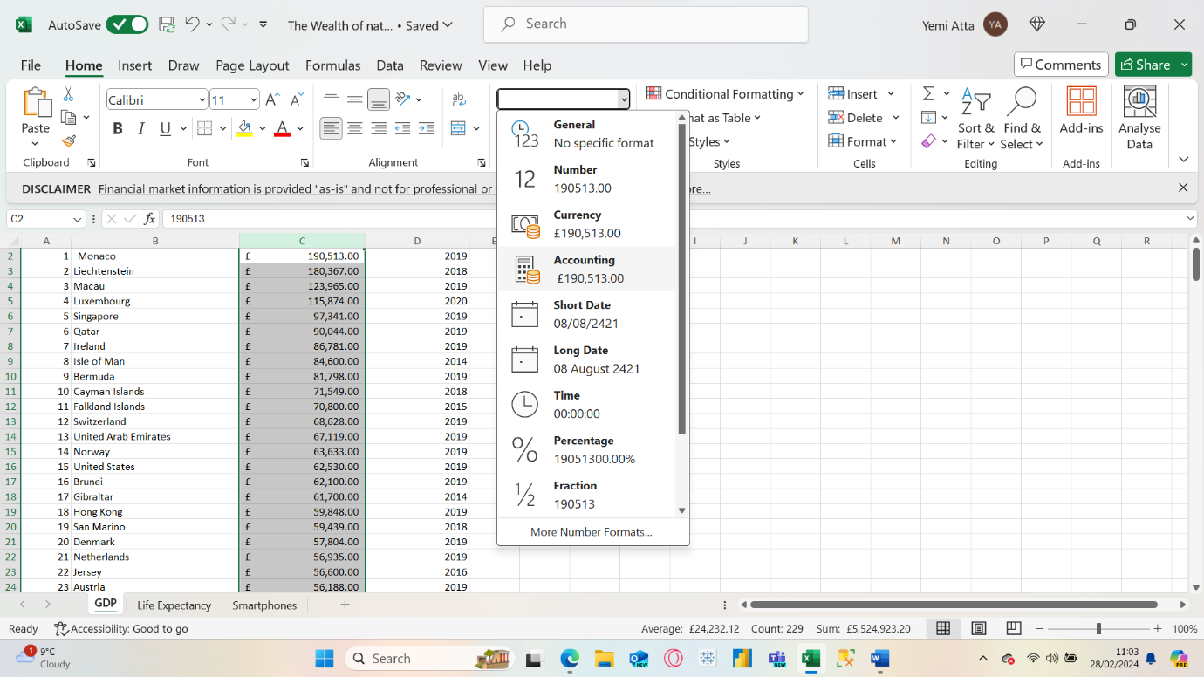

Transforming GDP Data into a Table

To transform data into a table, you will need to highlight all the data (columns and rows) that you want to have in your table. For this activity, I have selected all the data as I want all the information on this worksheet in a table. A shortcut is to highlight all fields then hold CTRL+T or you can manually go to the insert ribbon and select table and populate your table from there.

You can also edit your table from the table design ribbon.

Adding Filters to Table

Adding filters to a table is a great tool in excel and is used to manipulate the table to show you specific data based on your selected filter options. A shortcut for filters is to hold CTRL+Shift+L.

You could also apply filters to specific columns by highlighting the columns you want to add a filter option for. Once a filter has been successfully applied, you will notice that a drop-down icon should appear at the end of the title in the selected column. This is where we will be adding a filter to just show us data from the year 2019.

## A screenshot of a computer Description automatically generatedConnecting Data to Tableau to Build a Chart

Although you can create charts in excel, I believe using Tableau is more beneficial as it offers much more visualisation tools and options. When you open Tableau, you can retrieve data in many ways such as online datasets, importing through excel, databases on your desktop, etc. For this activity, I will be using the same data I have been working on, so the best option is to import from excel. Once this has been clicked, Tableau will give you display options where you can select the whole workbook or specific worksheets within a workbook. I have selected ‘GDP’ as this is the name of the worksheet previously used in excel that I want to display a visual report of.

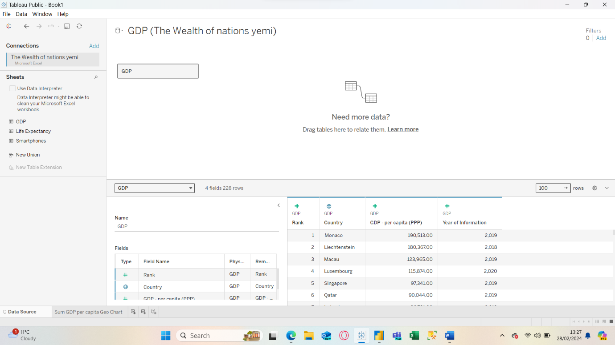

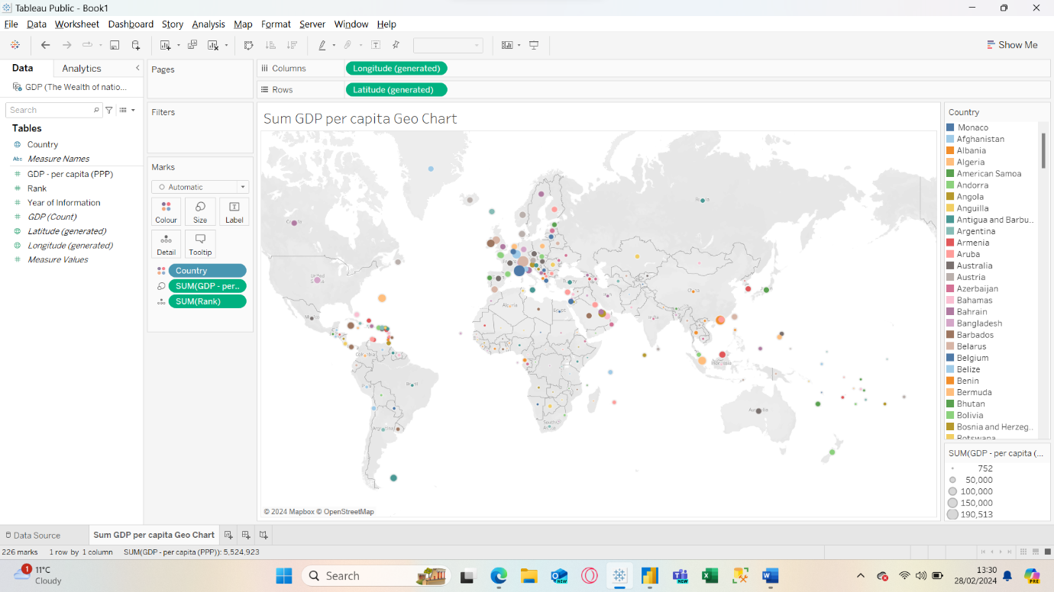Creating a Chart with Tableau

There are various types of charts that can be utilised within Tableau. As we will be looking at countries, I’ve decided to use a Geo map for visualising my findings. On the right is a legend highlighting each country and their assigned colour. Each country’s bubble size will vary; the bigger the bubble, the more GDP per capita that country has.

There are additional visualisation options on the left side of the page, situated in the marks pane. This is where you can explore creative visuals and make your reports more visually attractive whilst being easy to understand.

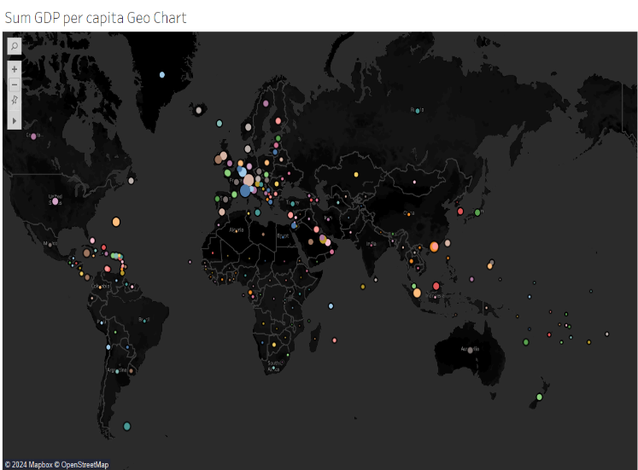

Because of the number of countries within my data, I have also opted to use a tree map to help visualise the selected data. Here you can see that the darker the shade of blue, the better the GDP per capita and ranking. Foe example Monaco has is the top ranked country as they have the highest GDP per capita. Hovering the mouse cursor over each tile will bring up stats related to the specific tile.

Sorting Table (Displaying Top 20 Ranked Countries)

To sort the table to show the top 20 ranked countries can be done in different ways. You could highlight the specific field then click the data ribbon at the top of the screen and select the top 20 ranked countries. Another way is to press the drop-down arrow (if you’ve previously added filters to your table) beside the field name, then proceed to select the specific range of data required. Your new table should now only show the top 20 ranked countries from your previous table as shown below.

Bar Chart of Top 20 Ranked Countries

The table above shows the top 20 ranked countries with edited titles for X and Y axis on the table below. To make a new bar chart displaying this data, you need to highlight the whole table then click insert and then click chart on the ribbon to begin customising your chart. You can pick from various types of charts such as line, stacked, scatter, etc. It is essential to choose the most appropriate chart to display your data. Once the chart has been created, there are multiple choices of design templates and styles, or you can manually customise your chart by using the format pane on the right side of your screen, which I prefer as this is where you can be very creative and explore various aspects of data visualisation.

# Data Visualisation with Tableau

Visualisation of Top 20 Ranked Countries by GDP

Once we have imported data, we can now set relationships and begin to create various visuals to help with the intended research. The above visual shows countries and their sum of GDP. As there are many countries on our list, we will be adding filters to only show the top 20 ranked countries. The visual below has been filtered to only show the top 20 ranked countries.

We have now created a visual chart displaying the top 20 ranked countries by GDP. This is the perfect opportunity to customise the chart, making it more appealing and easily accessible to all. As our client is colour blind, the colours being used should also be considered. Below is an example of colour-blind friendly charts.

Visualisation of Top 20 Ranked Countries by Life Expectancy at Birth

With our client’s needs in mind, we can now create another visual displaying the top 20 ranked countries. Below is a bar chart that represents the client’s request. Each country has been ordered by size (thickness), the thicker the bar, the higher the age in life expectancy at birth. Countries have also been assigned with a colour and this can also be found in the legend.

Visualisation of the Top 20 Ranked Country by Sum of Smartphone Users

The bar chart above displays the top 20 countries with the most smartphone users. Immediately, it is noticeable that both China and India have a much greater number of smartphone users than the rest of the other countries. This has also been represented by the diverging colour scheme. The choice of colours was made with the client in mind.

Dashboard

Here is the final dashboard with all the charts displaying relevant data for reporting back to our client.

# Reflection

This assignment was very beneficial as I got to show off some of the new technical skills learned on the bootcamp. I was able to extract and upload data from Microsoft Excel to Tableau for data visualisation reports for a specific client. Once the data has been extracted and data manipulation begins to help pull out the top 20 ranked in various tables/charts. Using the design tools across the pane in Tableau allowed me to display my data in various ways with different graphs and charts to display my findings.

Due to my client being colour blind, keeping his/her needs in mind when presenting my report was a little challenging. This was due to finding the appropriate colours to display in my graphs/charts to meet the clients needs. Luckily, Tableau has built in colour schemes that are colour-blind-friendly. Overall, the assignment was engaging and intuitive.

Yemi Atta.